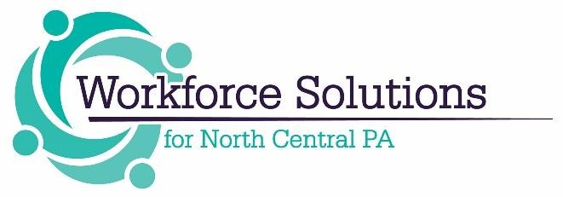

Manufacturing Training to Careers – Internship Program

Implemented by Workforce Solutions for North Central PA with funding Provided by the Department of Community Economic Development
Program Description

Workforce Solutions for North Central PA was awarded funding from DCED’s Manufacturing PA Training-to-Career Grant to support Internships in Manufacturing in our six-county region which includes the counties of Cameron, Clearfield, Elk, Jefferson, McKean and Potter through June of 2024. This internship program is a great strategy to assist in retaining our current population and increasing their awareness of the career opportunities in their own backyard. The goals of the internship are to introduce participants to the many manufacturing career opportunities as well as career pathways in our region encouraging them to stay or return after post-secondary education and providing manufacturing employers in our region with a workforce into the future. This internship program is intended to be a professional learning experience that offers meaningful, practical work related to a student’s field of study.

Eligibility Criteria:

- Employers – Manufacturing companies only.

- Participants – Interns must be:

- 18 years or older
- PA Residents
- Currently in or recently completed a manufacturing related field of study (Career and Technical Education, Industry Recognized training program, associate’s degree or higher).

- Occupations: Must be specifically related to the Manufacturing industry.

Other Requirements:

Applications will be reviewed as received on a rolling basis until funds are utilized.

Employers must agree to the following:
- Recruit and hire interns.
- Internship must take place between July 1, 2021– June 30, 2024
- Interns must be PA residents.
- Hourly wage must be at least $12.00 per hour for the length of the internship–Employers will be reimbursed for 50% of the wage for a maximum of $3,000.00.
- Interns must complete an Introduction to the Manufacturing Industry as well as complete all eight of the work readiness training sessions (soft skills training, resume building, interview skills, financial literacy, entrepreneurial skills, diversity training or prevention of workplace harassment training) – this can be done online utilizing Workforce Solutions’ virtual classroom. Details will be provided upon award.
- Employers must allow interns to participate in a Workforce Innovation and Opportunity Act (WIOA) overview and eligibility determination workshop.
- Ensure that interns complete all surveys to Workforce Solutions prior to the end of the program.
- Employer agrees the intern will participate in an Intern Essay – details will be provided upon award.
- Employer agrees to submit a photo/s of the intern.

Instructions for completing the attached application.

- Section 1: Employer Information – self-explanatory.
- For wage reimbursement amount – enter the hourly wage X 50% X hours per week. (Maximum reimbursement is $3,000.00)
- Section 2: Job Description – include job title, tasks to be completed, training to be provided/obtained, etc.
- Section 3: Employer match (50%) is required.
- Section 4: This section must be completed – the narrative will be utilized in making final award decisions.
- Section 5: Signature – by signing the application you agree to the conditions listed on this page.
- Upon approval, an agreement will be established between the applicant and Workforce Solutions that will outline the responsibilities of both parties as well as provide the reimbursement process and required documentation.

Employers should complete the attached application for an intern and submit to scunningham@ncwdb.org.

Applications will be reviewed and evaluated on receipt of application until all funds are depleted. Awards will be made within 1 week of approved application. If an application does not meet the requirements of the program, a Workforce Solutions staff will reach out to the applicant to assist with necessary corrections.

Thank you in advance for your application. Workforce Solutions is committed to our role in ensuring that our regional employers have access to a skilled workforce and know that we are in this together!

If you have any questions, please do not hesitate to contact us at 814-245-1835. We look forward to receiving your application. You will be contacted by Workforce Solutions upon approval of your application.

Equal Opportunity Employment Program Auxiliary Aids and Services are available to individuals with disabilities
Funding provided by: https://www.workforcesolutionspa.com/categories/resources/pages/stevens-amendment

